**Supplementary Table1 Four kinds of primers of present 13 studies**

|  |  |  |  |  |
| --- | --- | --- | --- | --- |
| **Author** | **Year** | **Forward （bp）** | **Reverse (bp)** | **Island(bp)** |
| Dong et al (2007, Korea) | 2007 | chr16:82,660,749-82,660,767 | chr16:82,660,652-82,660,673 | chr16:82660651-82661813 |
| Feng et al (2008, USA) | 2008 | chr16:82,660,749-82,660,767 | chr16:82,660,652-82,660,673 | chr16:82660651-82661813 |
| Hanabata et al (2004, Japan) | 2004 | chr16:82,660,749-82,660,767 | chr16:82,660,652-82,660,673 | chr16:82660651-82661813 |
| Hsu et al (2007, Taiwan) | 2007 | chr16:82,660,749-82,660,767 | chr16:82,660,652-82,660,673 | chr16:82660651-82661813 |
| Jin et al (2009, Japan) | 2009 | chr16:82,627,104-82,627,124 | chr16:82,627,187-82,627,206 | chr16:82660651-82661813 |
| Nikolaidis et al (2012, UK) | 2012 | chr16:82,660,654-82,660,671 | chr16:82,660,705-82,660,726 | chr16:82660651-82661813 |
| Toyooka et al (2001, USA) | 2001 | chr16:82,660,749-82,660,767 | chr16:82,660,652-82,660,673 | chr16:82660651-82661813 |
| Toyooka et al (2003, USA) | 2003 | chr16:82,660,749-82,660,767 | chr16:82,660,652-82,660,673 | chr16:82660651-82661813 |
| Tsou et al (2007, USA) | 2007 | chr16:82,660,709-82,660,729 | chr16:82,660,792-82,660,811 | chr16:82660651-82661813 |
| Ulivi et al (2006, Italy) | 2006 | chr16:82,660,749-82,660,767 | chr16:82,660,652-82,660,673 | chr16:82660651-82661813 |
| Wang et al (2008, China) | 2008 | NA | NA | chr16:82660651-82661813 |
| Zhai et al (2014, China) | 2014 | chr16:82,660,749-82,660,767 | chr16:82,660,652-82,660,673 | chr16:82660651-82661813 |
| Zhang et al (2011, China) | 2011 | chr16:82,660,749-82,660,767 | chr16:82,660,652-82,660,673 | chr16:82660651-82661813 |

NA: not found in the article.

**Supplementary Table 2 Differential CDH13 methylation, odds ratio between adenocarcinoma, squamous cell carcinoma and their counterparts from GSE39279 & GSE52401 dataset**

|  |  |  |  |  |  |  |  |
| --- | --- | --- | --- | --- | --- | --- | --- |
| **Type** | **Position** | **CpG site** | **McaM** | **McoM** | **∆β** | **p-valuea** | **p-valueb** |
| **LUAD** | chr16:82660670 | cg08747377 | 0.32658 | 0.1609 | 0.16568 | 1.11E-51 | 4.43E-28 |
| chr16:82660727 | cg05374412 | 0.23438 | 0.04392 | 0.19046 | 9.02E-77 | 1.29E-22 |
| chr16:82661421 | cg08856946 | 0.2117 | 0.07414 | 0.13756 | 2.63E-68 | 1.21E-24 |
| chr16:82661521 | cg13759328 | 0.28992 | 0.17442 | 0.11549 | 9.78E-61 | 1.29E-28 |
| chr16:82661638 | cg09189772 | 0.28967 | 0.1819 | 0.10778 | 2.63E-49 | 9.12E-26 |
| chr16:82661725 | cg19369556 | 0.27121 | 0.22947 | 0.04173 | 6.98E-09 | 6.44E-09 |
|  |  |  |  |  |  |  |  |
| **LUSC** | chr16:82660670 | cg08747377 | 0.23598 | 0.1609 | 0.07507 | 8.92E-12 | 1.61E-10 |
| chr16:82660727 | cg05374412 | 0.12757 | 0.04392 | 0.08365 | 3.65E-33 | 6.34E-14 |
| chr16:82661421 | cg08856946 | 0.14118 | 0.07414 | 0.06704 | 3.55E-30 | 6.01E-17 |
| chr16:82661521 | cg13759328 | 0.24259 | 0.17442 | 0.06817 | 2.59E-26 | 1.71E-17 |
| chr16:82661638 | cg09189772 | 0.23064 | 0.1819 | 0.04875 | 9.62E-10 | 1.51E-10 |
| chr16:82661725 | cg19369556 | 0.22208 | 0.22947 | 0.00739 | 0.005638311 | 0.145187084 |

McaM and McoM represent the mean of case methylation (Beta) and mean of control methylation (Beta). Methylation levels are calculated with formula: Beta = (M/M + U).

Position represents the chromosome position of each CpG site according to GRCh37/hg19.

P-valuea was calculated from Wilcoxon rank sum test after false discovery rate(FDR adjustment).

P-valueb was calculated from logistic regression analysis after false discovery rate(FDR adjustment).

**Supplementary Table 3 Differential 场3methylation, odds ratio between adenocarcinoma, squamous cell carcinoma and their counterparts from GSE56044 dataset**

|  |  |  |  |  |  |  |  |
| --- | --- | --- | --- | --- | --- | --- | --- |
| **Type** | **CpG site** | **Position** | **McaM** | **McoM** | **∆β** | **p-valuea** | **p-valueb** |
| **LUAD** | cg08747377 | chr16:82660670 | 0.31 | 0.07 | 0.24 | 3.73E-5 | 0.009 |
| cg05374412 | chr16:82660727 | 0.26 | 0.02 | 0.24 | 1.98E-5 | 0.03 |
| cg00806490 | chr16:82660873 | 0.25 | 0.07 | 0.18 | 1.20E-5 | 0.009 |
| cg08856946 | chr16:82661421 | 0.18 | 0.05 | 0.13 | 3.80E-5 | 0.02 |
| cg13759328 | chr16:82661521 | 0.22 | 0.10 | 0.12 | 3.80E-5 | 0.01 |
| cg09189772 | chr16:82661638 | 0.24 | 0.12 | 0.12 | 0.001 | 0.01 |
| cg19369556 | chr16:82661725 | 0.20 | 0.17 | 0.03 | 0.85 | 0.52 |
|  |  |  |  |  |  |  |  |
| **LUSC** | cg08747377 | chr16:82660670 | 0.17 | 0.07 | 0.10 | 0.02 | 0.08 |
| cg05374412 | chr16:82660727 | 0.10 | 0.02 | 0.08 | 0.16 | 0.21 |
| cg00806490 | chr16:82660873 | 0.15 | 0.07 | 0.08 | 0.003 | 0.08 |
| cg08856946 | chr16:82661421 | 0.11 | 0.05 | 0.06 | 0.14 | 0.17 |
| cg13759328 | chr16:82661521 | 0.19 | 0.10 | 0.09 | 0.008 | 0.08 |
| cg09189772 | chr16:82661638 | 0.18 | 0.12 | 0.06 | 0.24 | 0.27 |
| cg19369556 | chr16:82661725 | 0.15 | 0.17 | 0.02 | 0.15 | 0.50 |

McaM and McoM represent the mean of case methylation (Beta) and mean of control methylation (Beta). Methylation levels are calculated with formula: Beta = (M/M + U).

Position represents the chromosome position of each CpG site according to GRCh37/hg19.

P-valuesa are calculated from Wilcoxon rank sum test after false discovery rate (FDR adjustment).

P-valueb and ORb and 95%CIb are from logistic regression analysis with P-valueb were also after false discovery rate (FDR adjustment).

**Supplementary Table 4 Diagnosis sensitivity, specificity, accuracy and AUC based on logistic regression with fivefold cross-validation**

|  |  |  |  |  |  |
| --- | --- | --- | --- | --- | --- |
|  | **CpGsite** | **Sensitivity** | **Specificity** | **Accuracy** | **AUC** |
| **LUAD vs. Control** | cg08747377 | 0.884 | 0.774 | 0.82 | **0.866** |
| cg05374412 | 0.924 | 0.886 | 0.898 | **0.936** |
| cg08856946 | 0.894 | 0.818 | 0.85 | **0.896** |
| cg09189772 | 0.87 | 0.752 | 0.8 | **0.828** |
|  |  |  |  |  |  |
| **LUSC vs. Control** | cg08747377 | 0.756 | 0.572 | 0.686 | **0.658** |
| cg05374412 | 0.806 | 0.698 | 0.764 | **0.744** |
| cg08856946 | 0.758 | 0.7 | 0.734 | **0.722** |
| cg09189772 | 0.762 | 0.524 | 0.672 | **0.596** |
|  |  |  |  |  |  |
| **LUAD vs. LUSC** | cg08747377 | 0.784 | 0.768 | 0.776 | **0.816** |
| cg05374412 | 0.824 | 0.832 | 0.828 | **0.87** |
| cg08856946 | 0.802 | 0.756 | 0.78 | **0.83** |
| cg09189772 | 0.776 | 0.742 | 0.762 | **0.78** |

Logistic regression was conducted to perform the diagnosis analysis. Sensitivity, specificity, accuracy and AUC were derived from the test result of the model

**Supplementary Figure 1 Funnel plot to diagnosis of the publication bias**

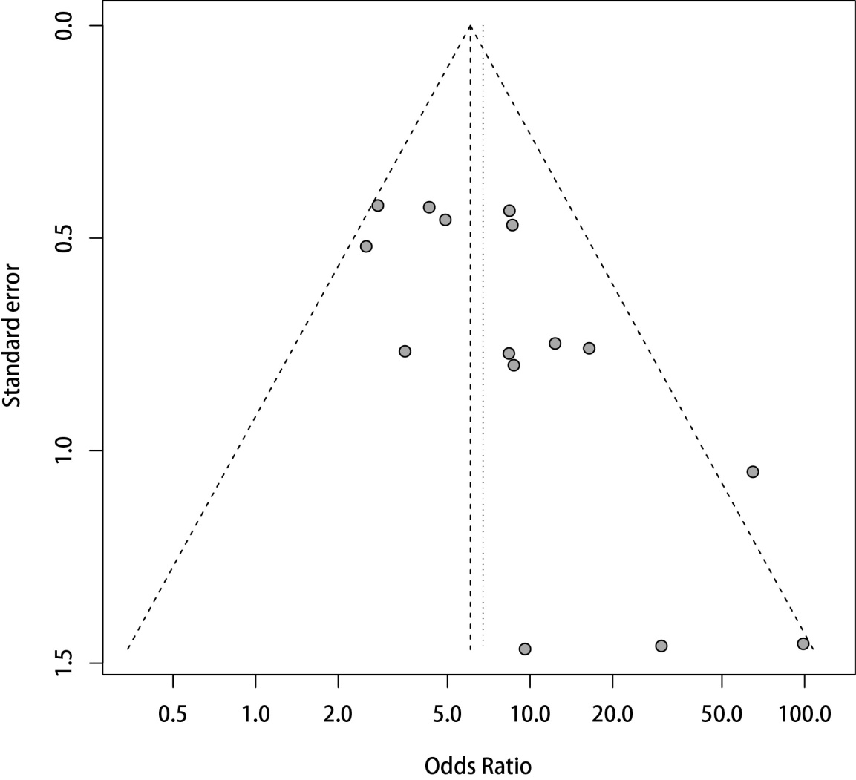

**Supplementary Figure 2 Combined estimates for the association between CDH13 methylation and NSCLC after trim-fill treatment.**

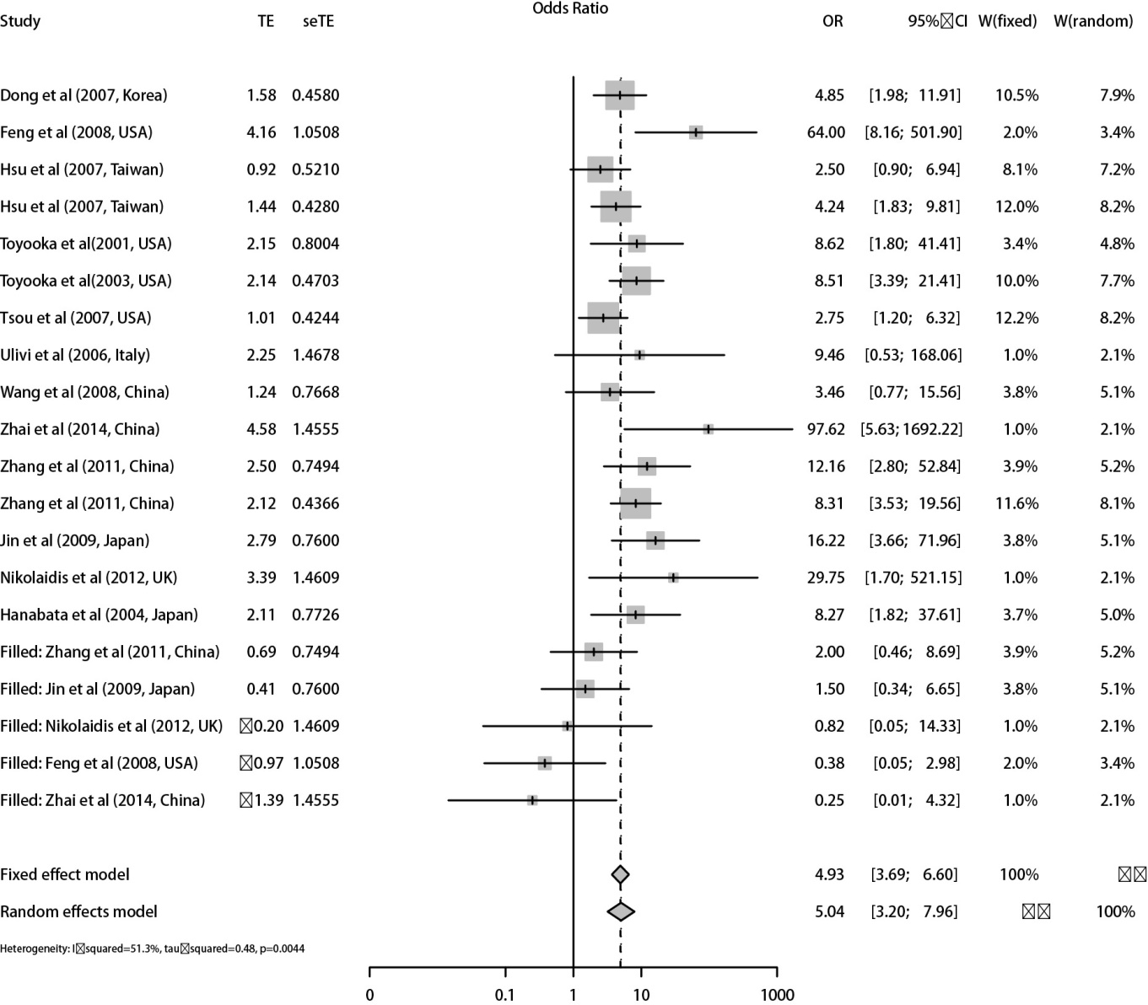

**Supplementary Figure 3 Sensitivity analyses of the overall effect by omitting a single study.**

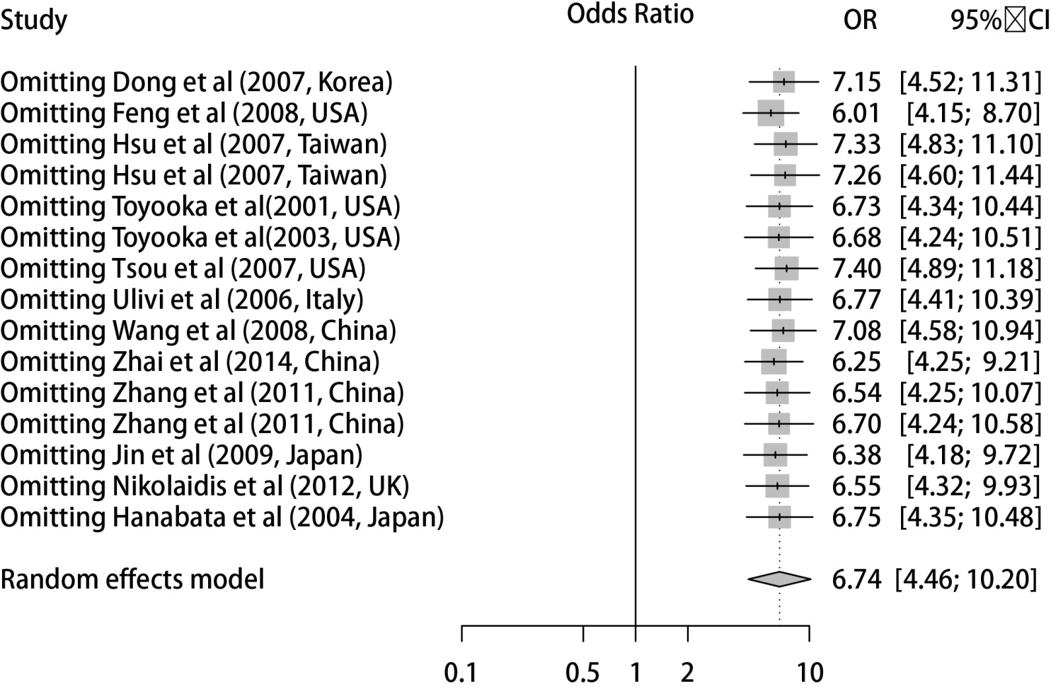

**Supplementary Figure 4 CpG sites on the Illumina Infinium HumanMethylation450 Beadchip array across CDH13 gene region from GSE39279 & GSE52401 datasets.**

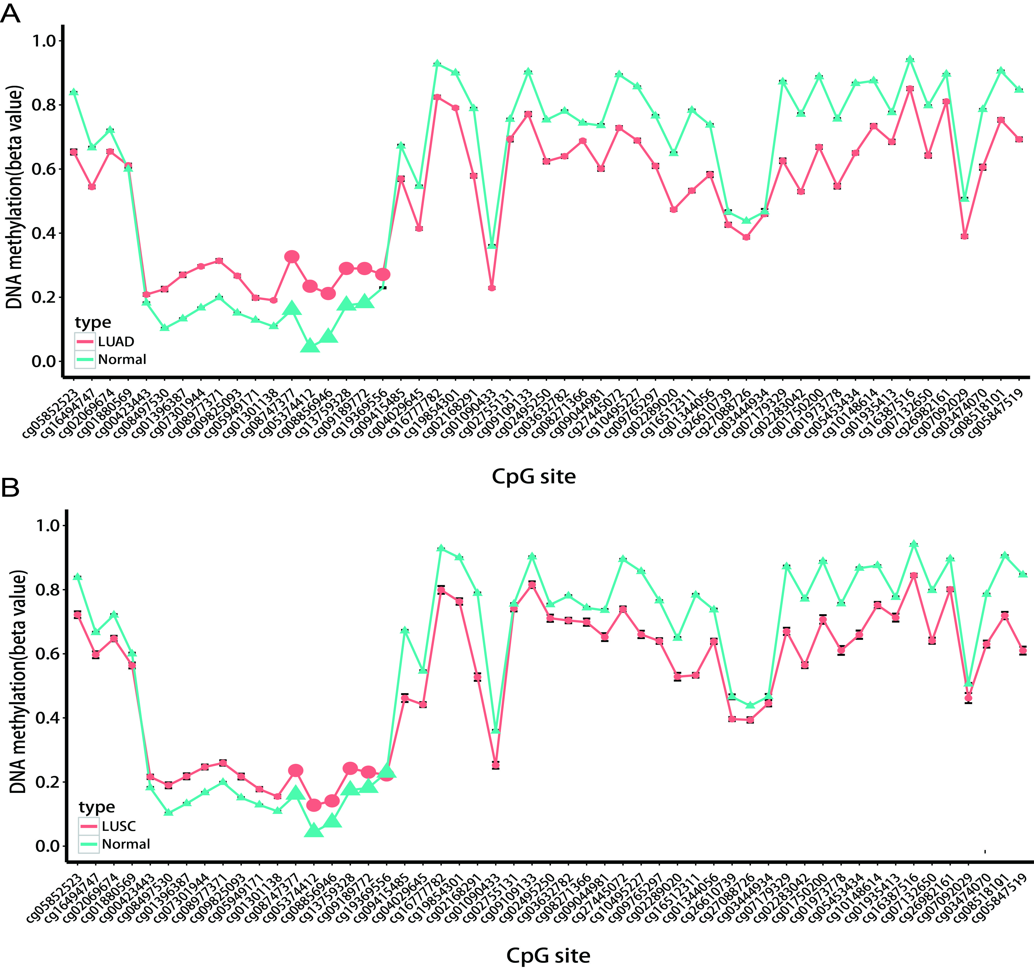

the x-axis showed the different CpG sites in CDH13 gene and the y-axis shows the beta value of each CpG site to represent the methylation level of each CpG site.

**Supplementary Figure 5 CpG sites on the Illumina Infinium HumanMethylation450 Beadchip array across CDH13 gene region from GSE56044 dataset.**

